EXP 01 : PASSPORT AUTOMATION SYSTEM

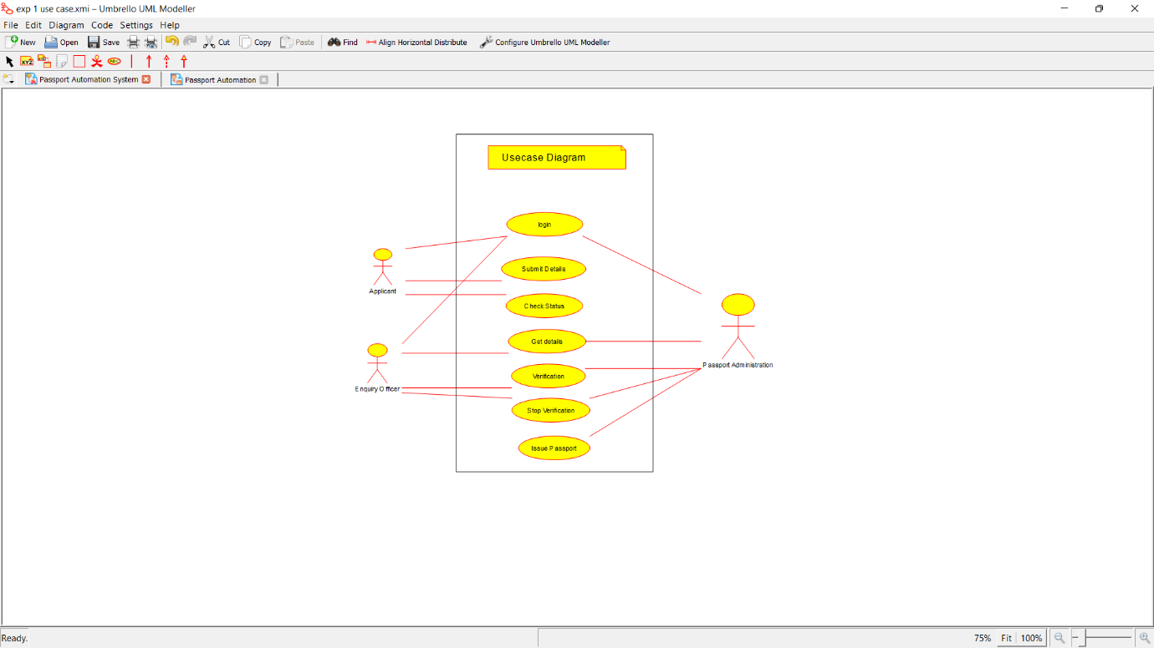

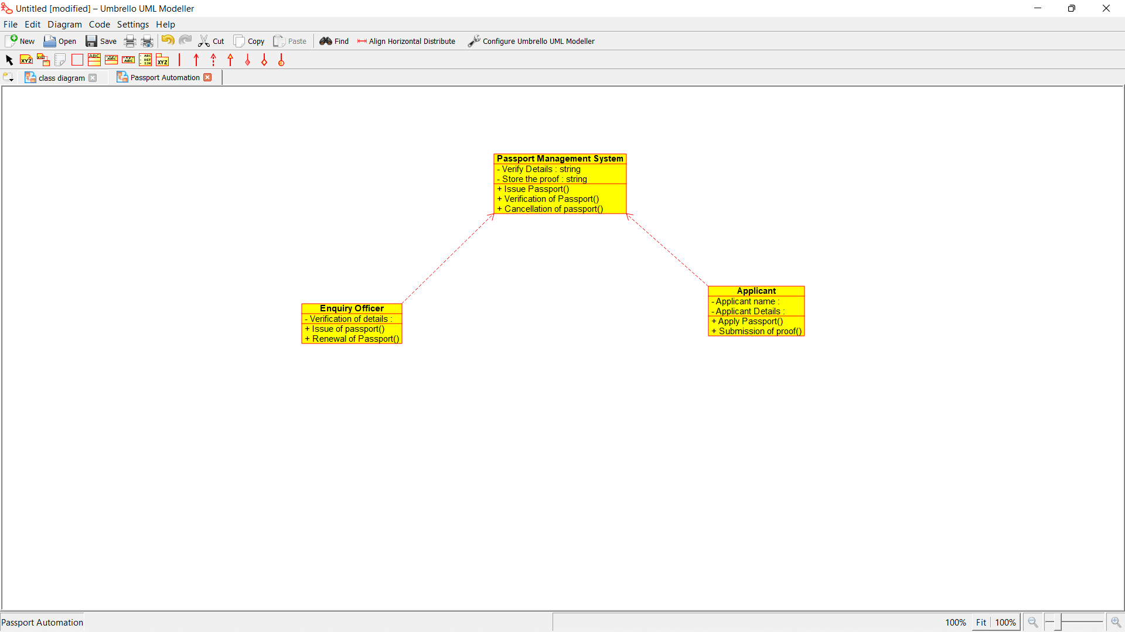

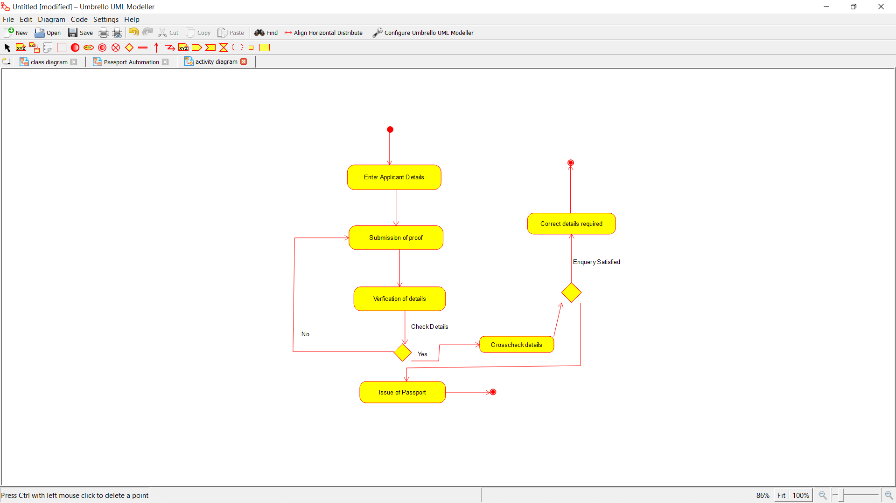

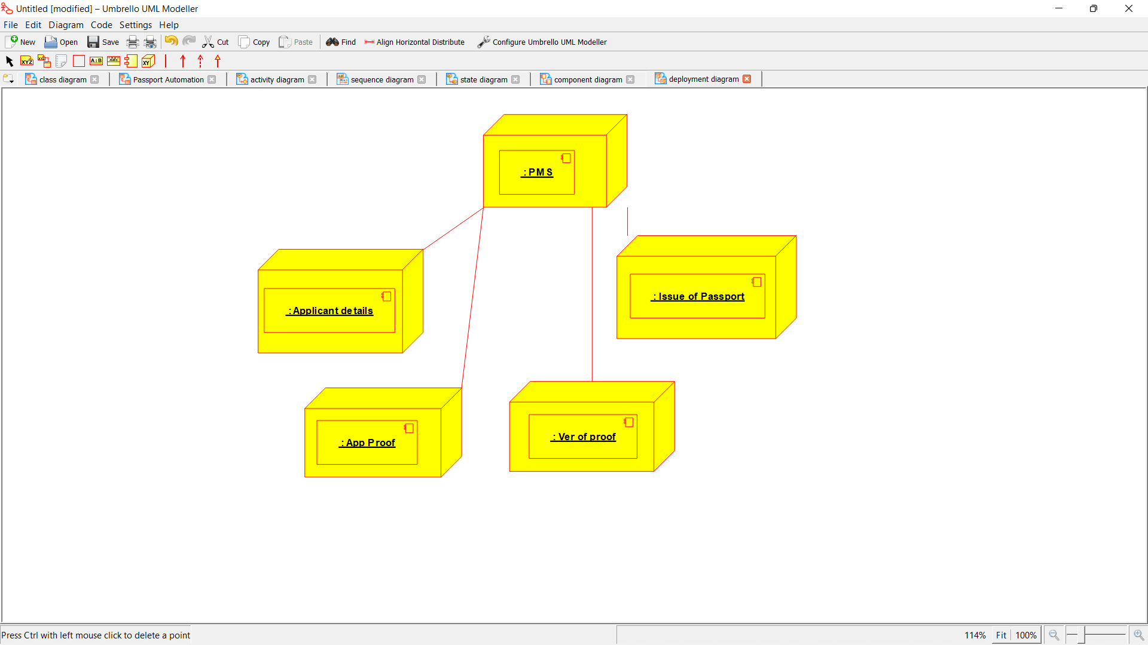

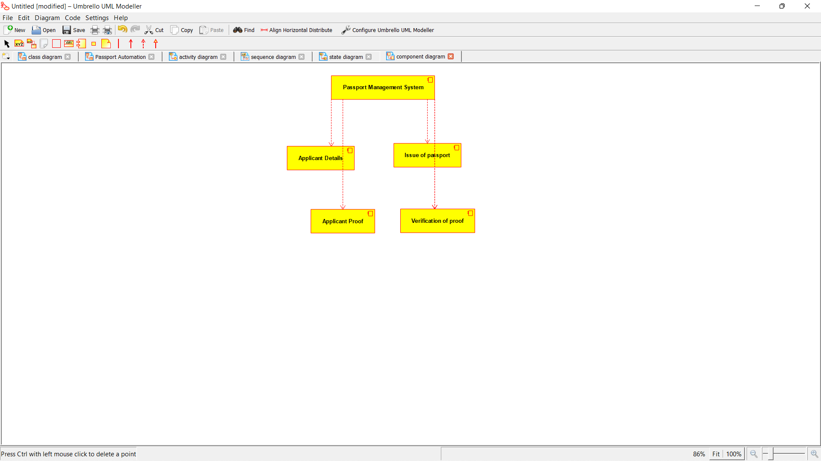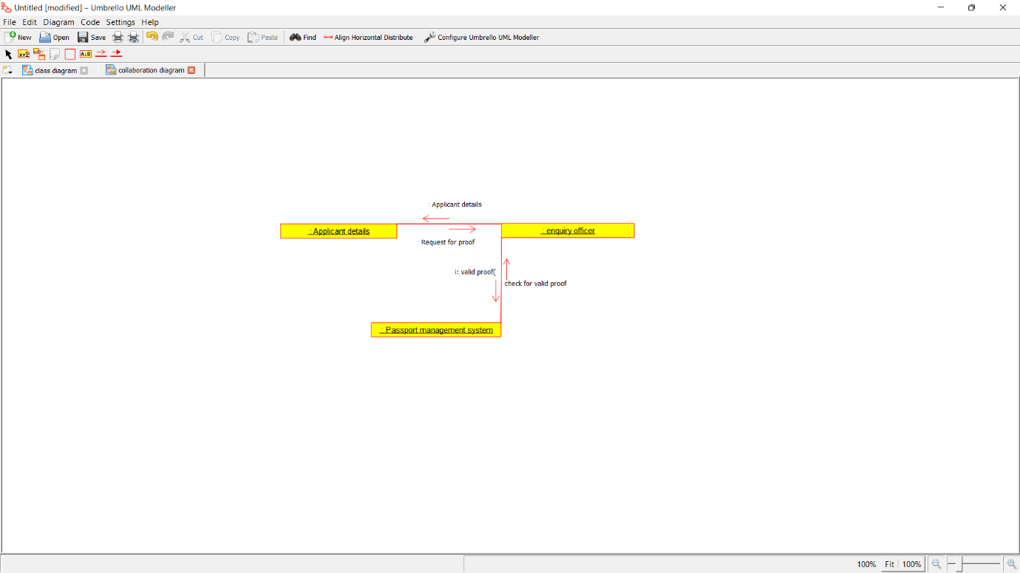

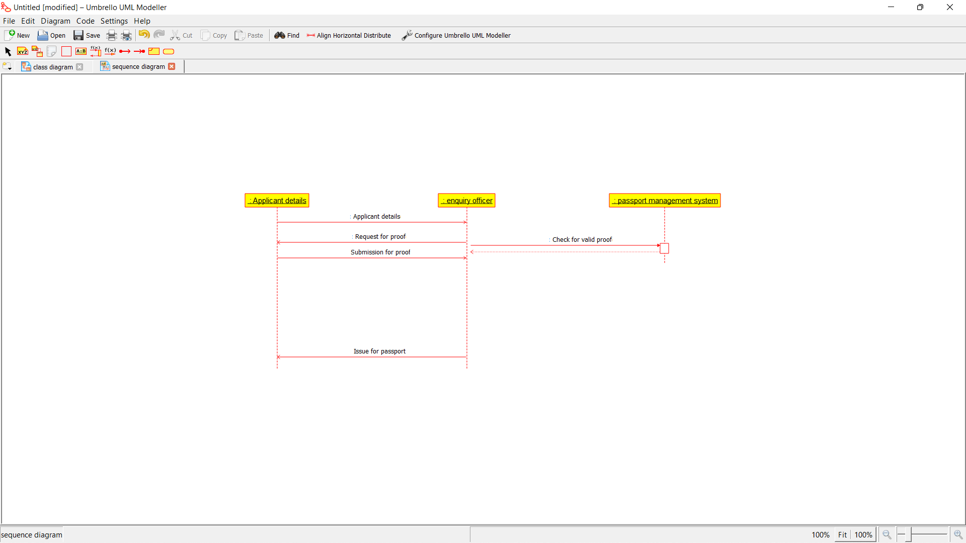

*Program coding:*

*/\*\**

*\* Class APPLICANT*

*\*/*

*public class APPLICANT {*

*//*

*// Fields*

*//*

*private void APPLICANT_NAME;*

*private String applicant_details;*

*//*

*// Constructors*

*//*

*public APPLICANT () { };*

*//*

*// Methods*

*//*

*//*

*// Accessor methods*

*//*

*/\*\**

*\* Set the value of APPLICANT_NAME*

*\* @param newVar the new value of APPLICANT_NAME*

*\*/*

*private void setAPPLICANT_NAME (void newVar) {*

*APPLICANT_NAME = newVar;*

*}*

*/\*\**

*\* Get the value of APPLICANT_NAME*

*\* @return the value of APPLICANT_NAME*

*\*/*

*private void getAPPLICANT_NAME () {*

*return APPLICANT_NAME;*

*}*

*/\*\**

*\* Set the value of applicant_details*

*\* @param newVar the new value of applicant_details*

*\*/*

*private void setApplicant_details (String newVar) {*

*applicant_details = newVar;*

*}*

*/\*\**

*\* Get the value of applicant_details*

*\* @return the value of applicant_details*

*\*/*

*private String getApplicant_details () {*

*return applicant_details;*

*}*

*//*

*// Other methods*

*//*

*/\*\**

*\*/*

*public void apply_passport()*

*{*

*}*

*/\*\**

*\*/*

*public void submission_of_proof()*

*{*

*}*

*}*

*/\*\**

*\* Class ENQUIRY_OFFICER*

*\*/*

*public class ENQUIRY_OFFICER {*

*//*

*// Fields*

*//*

*private String VERIFICATION_OF_DETAILS;*

*//*

*// Constructors*

*//*

*public ENQUIRY_OFFICER () { };*

*//*

*// Methods*

*//*

*//*

*// Accessor methods*

*//*

*/\*\**

*\* Set the value of VERIFICATION_OF_DETAILS*

*\* @param newVar the new value of VERIFICATION_OF_DETAILS*

*\*/*

*private void setVERIFICATION_OF_DETAILS (String newVar) {*

*VERIFICATION_OF_DETAILS = newVar;*

*}*

*/\*\**

*\* Get the value of VERIFICATION_OF_DETAILS*

*\* @return the value of VERIFICATION_OF_DETAILS*

*\*/*

*private String getVERIFICATION_OF_DETAILS () {*

*return VERIFICATION_OF_DETAILS;*

*}*

*//*

*// Other methods*

*//*

*/\*\**

*\*/*

*public void Issue_of_passport()*

*{*

*}*

*/\*\**

*\*/*

*public void renewal_of_passport()*

*{*

*}*

*}*

*/\*\**

*\* Class PASSPORT_MANAGEMENT_SYSTEM*

*\*/*

*public class PASSPORT_MANAGEMENT_SYSTEM {*

*//*

*// Fields*

*//*

*private String VERIFY_DETAILS;*

*private String STORE_PROOF*

*//*

*// Constructors*

*//*

*public PASSPORT_MANAGEMENT_SYSTEM () { };*

*//*

*// Methods*

*//*

*//*

*// Accessor methods*

*//*

*/\*\**

*\* Set the value of VERIFY_DETAILS*

*\* @param newVar the new value of VERIFY_DETAILS*

*\*/*

*private void setVERIFY_DETAILS (String newVar) {*

*VERIFY_DETAILS = newVar;*

*}*

*/\*\**

*\* Get the value of VERIFY_DETAILS*

*\* @return the value of VERIFY_DETAILS*

*\*/*

*private String getVERIFY_DETAILS () {*

*return VERIFY_DETAILS;*

*}*

*/\*\**

*\* Set the value of STORE_PROOF*

*\* @param newVar the new value of STORE_PROOF*

*\*/*

*private void setSTORE_PROOF (String newVar) {*

*STORE_PROOF = newVar;*

*}*

*/\*\**

*\* Get the value of STORE_PROOF*

*\* @return the value of STORE_PROOF*

*\*/*

*private String getSTORE_PROOF () {*

*return STORE_PROOF;*

*}*

*//*

*// Other methods*

*//*

*/\*\**

*\*/*

*public void Issue_of_passport()*

*{*

*}*

*/\*\**

*\*/*

*public void verification_of_passport()*

*{*

*}*

*/\*\**

*\*/*

*public void cancellation_of_passpott()*

*{*

*}*

*}*